Design, Development, and Implementation OF A Terminal Based PIC32 Interface

A Senior Project Submitted to the
Department of Computer Systems Engineering Technology
of the School of Engineering, Technology, and Management at the Oregon Institute of Technology
in partial fulfillment of the requirements for the Degree of

Bachelor of Science
IN
Software Engineering Technology
and
Bachelor of Science
IN
Embedded Engineering Technology

Callahan Barkman

© December 2014

Senior Project Approval Page

The senior project of Author 1, Author 2, and Author 3 for the Bachelor of Science degree was accepted by the evaluation committee and the Department of Computer Systems Engineering Technology at the Oregon Institute of Technology.

COMMITTEE APPROVALS:

____________________________________________________________
Jay Bockelman, Program Director (Oregon Institute of Technology)

____________________________________________________________
Reviewer 2 (Oregon Institute of Technology)

____________________________________________________________
Reviewer 3

____________________________________________________________
Reviewer 4

abstract

The abstract for the project goes here. The abstract serves as an executive summary of your project. It should include a brief introduction to the project, state its relevance, describe the design features, and provide a short summary or conclusion. The abstract should be structured in three or four paragraphs and it should not be longer than a page. It is typically written after you have completed the project. (1 page)

acknowledgements

The acknowledgements go here. You may want to check some acknowledgement sections in books or textbooks to get an idea of the tone and content of the typical acknowledgement. It may also be a good idea to take a look at some Master’s Thesis, Doctoral Dissertations, or other Senior Projects to get a sense of the tone and language typically used in the acknowledgments section. It is typically written after you have completed the project. (1 page)

List of Acronyms

Acronym Definition (The acronyms should be listed in alphabetical order)
Acronym Definition
Acronym Definition
Acronym Definition
Acronym Definition
Acronym Definition
Acronym Definition
Acronym Definition
Acronym Definition
Acronym Definition

VGA Video Graphics Array

List of Key Terms

Term Definition (The terms should be listed in alphabetical order)
PS/2 A 6 pin mini din connector for keyboards. Uses a 2 line communication method, data and clock at a very low rate (10 - 16.7 kHz) with a 5v power source for signal reference.
VGA Video Graphics Array – A type of video interface that originated in CRT monitors. Uses analog signals to describe colors usually. Uses timing for resolution and synchronizing pulses for horizontal and vertical sync to frame the data.
TCP/IP
SSH
Terminal
Linux
UNIX
*NIX A general term for any UNIX like system, ex: Linux, BSD, Solaris, etc.
SPI
UART
CAN bus
DMA
A/D conversions
Video Frame
Video Line
Pixel
Pixel Clock
Term Definition

Summary Table of Contents

Chapter 1 Introduction 10
Chapter 2 Background 14
Chapter 3 Functional Description 17
Chapter 4 Detailed Description 22
Chapter 5 Test Results & Validation 23
Chapter 6 Economic and IP Analysis 24
Chapter 7 Summary 25

Table of Contents

Chapter 1 Introduction 10
Overview 10
Product Description 10
Existing Products 11
Summary 13
Report Outline 13
Chapter 2 Background 14
Overview 14
Background Information 14
State of the Art 15
Summary 15
Chapter 3 Functional Description 17
Overview 17
Functional Description 17
Block Diagram 17
Summary 20
Chapter 4 Detailed Description 22
Overview 22
Detailed Description 22
Architecture 22
Summary 22
Chapter 5 Test Results & Validation 23
Overview 23
Test Plan 23
Test Results 23
Discussion 23
Summary 23
Chapter 6 Economic and IP Analysis 24
Overview 24
Engineering Economic Analysis 24
Intellectual Property Analysis 24
Summary 24
Chapter 7 Summary 25
Overview 25
Project Summary 25
Future Direction 25
Concluding Remarks 25

Introduction

Overview

Provide an overview of the chapter here. What does this chapter cover.

[This section should be written during the first term of the senior project sequence.]

Product Description

Explain and clearly define the problem you are addressing in your project/product. Include a specification of the characteristics. (2 pages)

In this product I will have the capability to communicate with a PIC32 through a PS/2 keyboard for input, and a VGA monitor for output. It will use the terminal pattern of communication, keys typed onto a keyboard correspond to characters being displayed on the monitor. Modifying keys such as Shift, Ctrl, and Alt cause different characters to be displayed. There will be an underlying operating system that will interpret the key press combinations when they are terminated by a control character such as carriage return.
The core of this project is creating a terminal display that can display characters that are entered through a keyboard. The system will be able to relate that information to computer using a method of communication they both understand, such as RS-232 or SSH.
The level of video processing I need for this project is quite minimal, as a screen resolution of 640x480 is enough to display a full standard terminal size of 80x24 characters. The hope is to be able to produce an 800x600 monochrome video for a bit better looking terminal, but there is room to expand the system to be able to do a 800x600 color video display if I decide I wish do to a video decryption project. If I go down the path of video decryption, this project could steam a 800x600 video window from a computer to allow for an external monitor display, possibly even over a TCP/IP connection.
There are several use cases that come to mind while using the classic terminal pattern of keyboard input and monitor output. The original terminal was a computer that connected to a UNIX mainframe to allow many users to use a larger central computer. The operating principle was that a central computer was expensive and should handle most of the processing and a terminal should do as little processing as possible to make it as inexpensive as possible. With several terminals, many users could use a large expensive machine at the same time for a cheap cost at adding each additional user.
The terminal is still used often in a modern environment. The terminal is typically used to connect to a computer over a TCP/IP connection using a security protocol called SSH, or as an emulation program to allow communication with the underlying *NIX system like in OSX or Linux. This project could become robust enough to have a full SSH implementation to use with modern Linux systems, but if SSH is too difficult to implement, I can still create an unsecure method of communicating with the Linux system. This unsecure method could be either a simple RS-232 connection, or an unsecure method of using TCP/IP.
If a user has their desktop Linux computer stop responding to input, this product could provide an inexpensive secondary device that allows a user to connect over SSH to correct the problems of the system. Another use case for the terminal interface is that it is possible to use a terminal interface to display status information from shell commands like top that regularly update the window. This device would allow that information to be tied to an unused monitor for independent output. These are just a few functions of having a cheap external device to be able to communicate with a bigger system.
If there is enough time, the device should also be able to use the many hardware features of the PIC32 such as A/D conversions, SPI serial interfaces, UART serial interfaces, CAN bus interfaces, and DMA to add to the usability of the product.
The critical part of this project will rest in how far I can get with the video display portion of the project by a critical progress marker.
If I get far enough, a major section of use cases could be creating a scripting language to facilitate interactions between parts of the PIC32 system in an easily modifiable way. If the system is organized logically, it could be used for educational purposes. Being able to directly control I/O pins or serial devices allows for an easy to advanced control system. If the scripting language is one that is already used elsewhere, the things learned could be transferred over to other systems, increasing the learning potential, or even increasing the potential for people who are familiar with other systems to use this product.
Alternately, the keyboard and monitor are so commonly used that there is a large market for microcontrollers or even PC computers needing an easy to use external device to interface with their system. This product should be easy to interface with, and additional methods of interface such as I2C and SPI terminals will easily extend the system to new markets.
A common issue with embedded devices is having a way to communicate with their serial interfaces as most modern computers don’t have 9 pin DIN connectors. If this system is able to be a serial terminal for those devices, it could bring yet another set of use cases to the system. In addition, most computers don’t have an easy to use SPI or I2C device, meaning it could be used to display information being sent over those interfaces. A specific use case I can think of was my Lab 6 in the class CST 337, where the serial device that I was using through USB didn’t have drivers for windows 8. If the device was separate of things like window’s versions it could always be used for that lab as a separate device that would be about as expensive as the USB to RS-232 cable was.

[This section should be written during the first term of the senior project sequence.]

Existing Products

List the existing products that perform similar tasks to yours. Contrast the features. Show pictures. (2 pages)

[This section should be written during the first term of the senior project sequence.]

http://duinomite.com/
Duinomite - $25 BASIC scripting/compiler. VGA output, PS/2 input, I/O control

http://dl.acm.org/citation.cfm?id=563297
Enhanced terminal interface paper.
Uses touch screen interfaces to display and manipulate multiple types of symbols that are programmable by the user.
Doesn’t offer an actual built product, just the sale of the paper.

http://www.rowebots.com/khxc/cms-display/splash.html
Closed source (free trial, costs to develop with)
Suggested price for a developers license of a POSIX compliant PIC32 kernel, file system, and serial I/O: $999.99
With IPv4 TCP/IP (+$1599.20) and SSH (+$3199.20)
Total: $5798.39
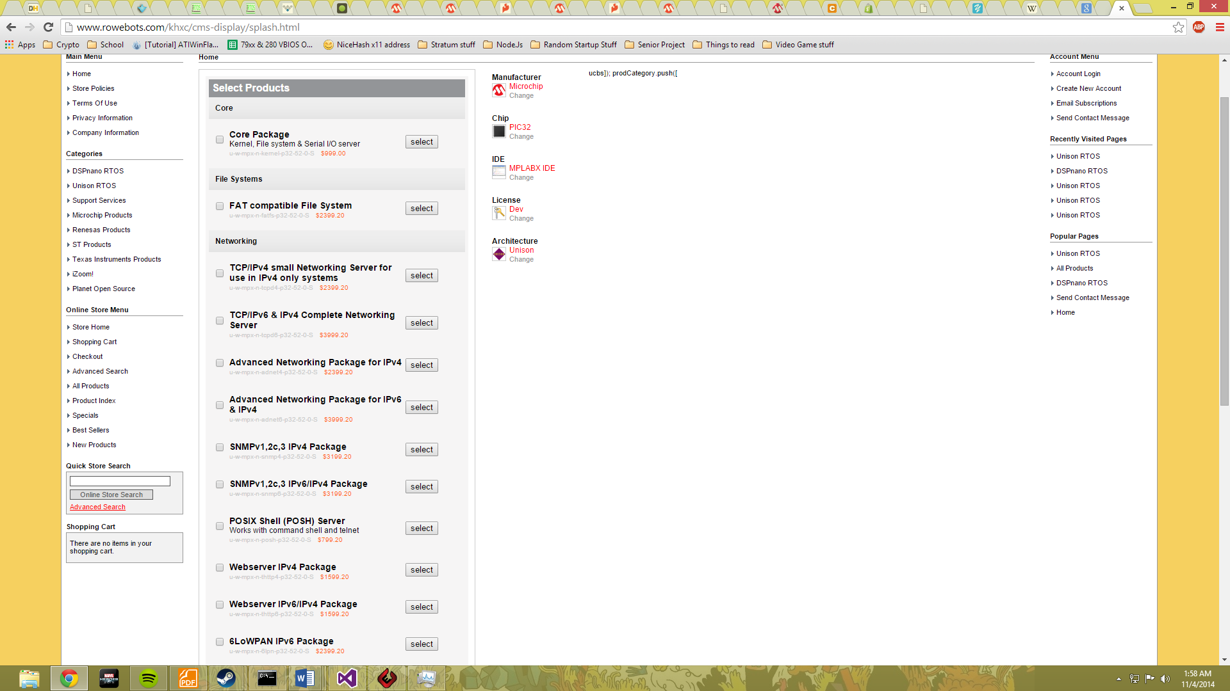

http://www.newark.com/raspberry-pi/raspbrry-modb-512m/model-b-assembled-board-only/dp/43W5302?COM=superwidget-link_RaspberryPiModelB
Rasberry pi:$35.00
HDMI video, USB keyboards, Linux OS that has Ethernet IPv4 TCP/IP and SSH
Open source

https://www.sparkfun.com/products/12053
Arduino Yun: $71.95
Linux OS with IPv4 TCP/IP and SSH, no video or keyboard input
Open source

http://www.vetco.net/catalog/product_info.php?products_id=13624&gclid=CPDP16nf4MECFcNffgod7KgAPg
If I cant get VGA working, here is a $10 screen with an SPI interface to use
Idea: could use SPI or I2C as video input devices too for more extension
Or maybe even as SPI or I2C debuggers (show all the outputs that are clocked through if I can, ect?)

Summary

[This section should be written during the second or third term of the senior project sequence.]

Report Outline

Provide an outline of your report – what you will be covering in this report, the order of the report itself and supporting data.
[This section should be written during the first term of the senior project sequence.]

Background

Overview

Provide an overview of the chapter here. What does this chapter cover.

[This section should be written during the first term of the senior project sequence.]

Background Information

Provide any background details necessary to understand your project. (1-2 pages)

Long before the mouse, the interface of keyboard and monitor dominated the computing market in a compact package called a terminal. A terminal is characterized by the keyboard for input, monitor for output, and a network communication method to let it talk to other devices. The idea of a terminal is integral to the history of computing due to UNIX style systems being designed to have a central computer that multiple terminals could communicate with. This eventually evolved into graphical user interfaces but the idea of using simply a keyboard and monitor to use a computer has not died out. Almost every modern Linux and UNIX graphical interface has their version of a terminal emulator. This leads me to believe that there is still a need for the terminal interface.
In the spirit of trying to be as economic as possible, I shall try to make a useful terminal interface for as low of a cost as possible. If done properly, it should be easy to deploy a central Linux system for low cost and connect multiple custom clients in a text only terminal format for a fraction of the cost of a modern PC. I could do this over a standard RS-232 which would be good for interfacing with older systems, possibly giving me an opportunity for sales in the backwards compatibility market. There is also a hope I can do things over TCP/IP securely with a program like SSH. If this proves too much I can always implement things over a less secure method like telnet.
The best part about a terminal based interface being implemented with a PIC32 is that there is enough room on the system to add an Operating System. With a custom OS and a custom shell I could facilitate many other uses that just a terminal wouldn’t be able to achieve. With the addition of a memory card and the ability to process scripted statements I could create an environment that could be heavily extended. For example I could pass along data from a sensor over TCP/IP or RS-232, wire sensors to an alarm circuit, record data from other serial interfaces like I2C and SPI, A/D conversions, or a number of other things that the PIC32 hardware supports. The more powerful I make the scripted language, the more powerful the system becomes.
I will be using a standard TCP/IP internet connection due to its common place use in modern computing. This interface will allow a very large range of other devices to communicate with the project. If standard SSH is implemented on top of this, any modern *NIX system will be able to communicate with the project.
I am using VGA as a display method as the color video takes a series of pins instead of a function of analogue methods like the NTSC standard. The pixel clock is a lot higher, but that will also allow for sharper edges, making text stand out better on.
The method of keyboard input has been selected as PS/2 as it is a 2 wire serial interface using a very slow and therefore simple to use clock and data rate. A USB keyboard was considered, but the USB communication method is very complex due to it being able to communicate with so many types of devices. In addition to the complexity, the footprint for the USB stack would bloat the system and leave less memory for the user.

[This section should be written during the first term of the senior project sequence.]

State of the Art

Provide an overview of the state of the art. (1-2 pages)

The modern version of the terminal is one that is usually emulated. In a Linux or BSD system, there is a terminal that allows for direct communication with the operating system. In modern Windows systems, there is a terminal emulator that allows for textual interface with the windows system, but the commands run activate buried windows functions, as opposed to Linux where the text is the true commands and the window dressing simply activates series of textual commands.
The terminal is also used very commonly with the security protocol SSH. Secure SHell is an encoded method of textual interface that allows a person to access a terminal on a remote system over TCP/IP connections. This allows for remote use of systems without the need for exposing a website or other control method. Importantly, due to the very low level of bandwidth and processing required for an SSH session, many people are able to access and use the same system without a noticeable degradation in performance. The SSH program and terminal program do not interpret any functions themselves, however, they do act as secure methods to which the user can interact with the system shell.
The shell is the interpreter for textual interface with a system. The most commonly used shell for Linux is BASH, or the Bourne Again SHell. In addition, most Linux systems also support SH, or the Bourne Shell, for backwards UNIX compatability. Other shells for linux include CSH, or the C SHell, tsch, or Tennix C Shell, and ksh, or the Korn shell.

[This section should be written during the first term of the senior project sequence.]

Summary

Summarize the chapter

[This section should be written during the first term of the senior project sequence.]

Functional Description

Overview

Provide an overview of the chapter here.

[This section should be written during the first or second term of senior project sequence.]

Functional Description

Provide a functional description of your design. (1-2 pages)
This system is characterized by the display pattern of the terminal. This pattern creates a feedback loop for the user to interact with the system. Through this feedback, a user can have a high rate of communication with a system. This can facilitate many different user interactions, and is easily extendable. Combined with this user interaction, this system will provide communication over TCP/IP to allow interfacing with other systems. The system may also potentially allow for communication with other built in PIC32 peripherals like serial devices or A/D conversions. With the addition of a shell environment, it may be easy to create a simple sensor that pipes information over the TCP/IP interface to another computer through utilizing parts of this system.

[This section should be written during the first or second term of senior project sequence.]
Block Diagram
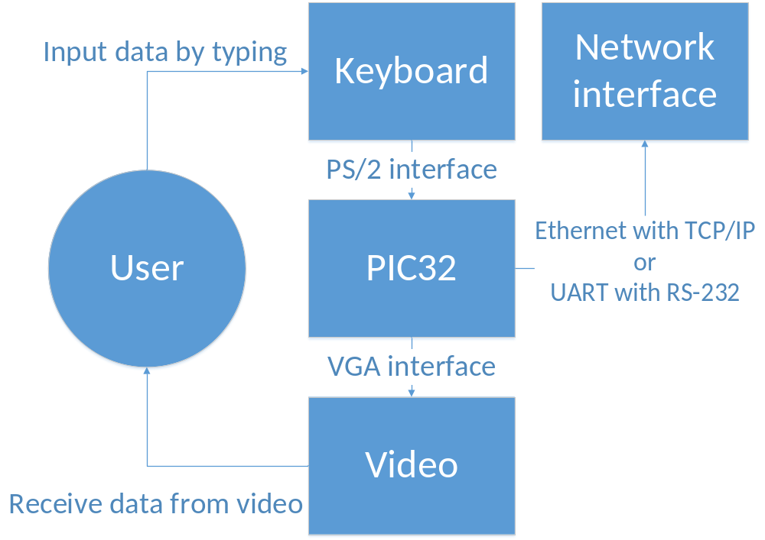 This is a block diagram of the hardware in the system. The major portion is the feedback loop presented to the user by way of video and keyboard interfaces. The video is provided to the user by a VGA style connection, and will update regularly to inform the user of software changes. The keyboard communicates over a PS/2 style connection and will allow the user to control the system, with changes being reported by video.
Now that the user can enter and view information, the system will also change its display depending on network or device communication. The typical pattern of usage is: enter a key on the keyboard, have it interpreted by the OS, and then have the entered character appear on a screen. Once a series of characters are on the screen, a control key will be pressed which will prompt the system to interpret the series of characters in a shell. This shell could simply be a pass through for SSH, or a custom shell built to control the system’s other peripherals.

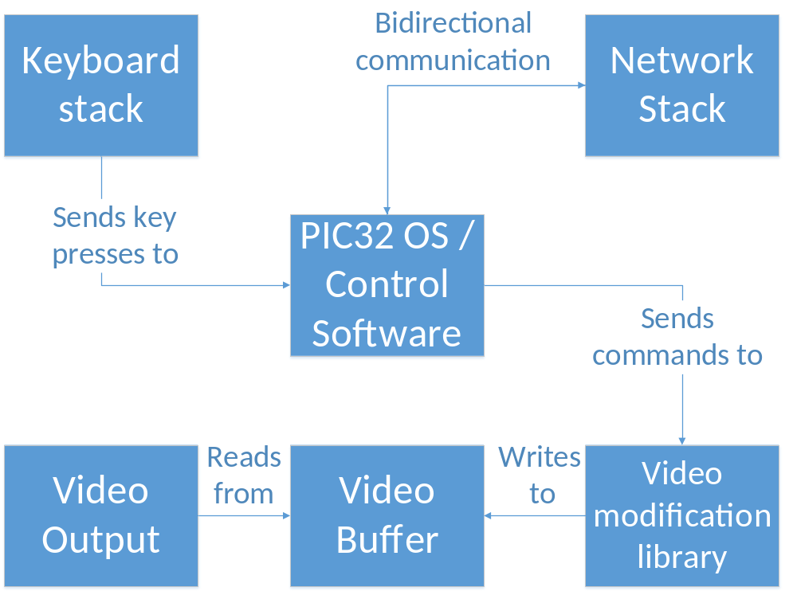
This is a block diagram of the major software areas of the project. The PIC32 OS/Control Software is the main block and will directly control or be controlled by the other blocks. The Keyboard stack interprets key presses and send the interpreted information to the PIC32 OS/Control Software. The Network Stack should allow for TCP/IP communication with other TCP/IP devices. It can give incoming information to the PIC32 OS/Control Software, or send information to the internet from the PIC32 OS/Control Software. The TCP/IP stack will possibly contain an SSH module in the future if SSH becomes implemented.
The video modification library takes input from the PIC32 OS/Control Software and modifies the video buffer. The video buffer is a non-locking block of memory that will allow for simultaneous reads and writes of memory, as a partially updated frame will not be a big deal as long as it does not take several video frames to modify the image. The video buffer will be read by the video output module at a regular interval of once per video frame.
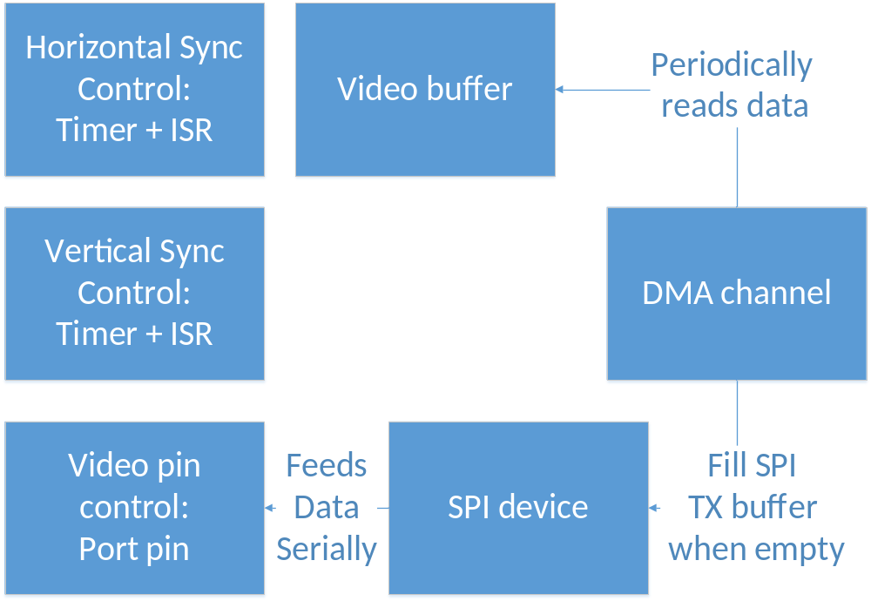
This is a block diagram of the video output block in the former diagram. It explains how the video signals are generated and how the PIC32’s hardware will be utilized. To begin, there are two sync pulse generating objects, the Vertical Sync Control and the Horizontal Sync Control. They both generate pulse signals at regular intervals, and frame the video. These objects will remain independent of other control methods, besides a possible enable/disable bit.
The video buffer will be read by a DMA channel, allowing for an entire video line to be transferred in sections until complete. The DMA channel will provide the data for each line to an SPI device, which has a serial shift register that will allow for the shifting out data bits at exactly the speed of the pixel clock, regardless of the system clock. As the DMA channel will keep the video information provided to the SPI device regularly, the SPI device will proceed to display each line in a frame. The great part about this design is that it is possible to use 3 SPI devices and 3 DMA channels to provide 3 video images, one for red, green, and blue, allowing color video display.
[This section should be written during the first or second term of senior project sequence.]

Summary

Summarize the chapter

[This section should be written during the first or second term of senior project sequence.]

Detailed Description

Overview

Provide an overview of the chapter here.

[This section should be written during the second or third term of senior project sequence.]

Detailed Description

Provide a functional description of your design. Make sure to include pictures and figures of your design. (3-5 pages including figures)

Hardware:
The detailed description of this project is divided into three major sections, the PS/2 interface, the VGA interface, and the TCP/IP interface. Each of these sections operates independently on the hardware level, with the only overlap being handled by the interrupt controller as it has a priority encoded scheme for which order hardware devices get serviced in software.
The PS/2 interface has an input capture device which detects falling edges on the PS2CLK line. At each falling edge, the data line is sampled, and once a full PS/2 packet has been received, it is interpreted by the system.
The Ethernet port interface is controlled by a TCP/IP PHY which is a physical device to help mediate TCP/IP communication so the Pic32 has time to process other information while the PHY takes care of the raw TCP/IP handling. The PHY talks to the Ethernet Magnetics where the data coming from the PHY is converted from 0V to 3.3V signals to the -12V to 12V signals that make up Ethernet communication.
The VGA port interface is controlled by 3 signals; video, H-sync, and V-sync. The video signal is produced by a SPI device shifting out data at 40mhz, the pixel clock speed of 800x600 VGA video. The SPI device is a small buffer (4x32 bits) and it must be fed data regularly by the DMA. H-sync is produced on regular intervals by a timer module, and the duty cycle of the produced PWM is set and controlled by the output comparator. This signal is also fed back to the Slave Select line of the SPI device, causing the SPI device to have hardware framing for video. This means that the SPI device won’t accidentally print data when not in the middle of a video line. V-sync control is done entirely in software in the timer ISR.
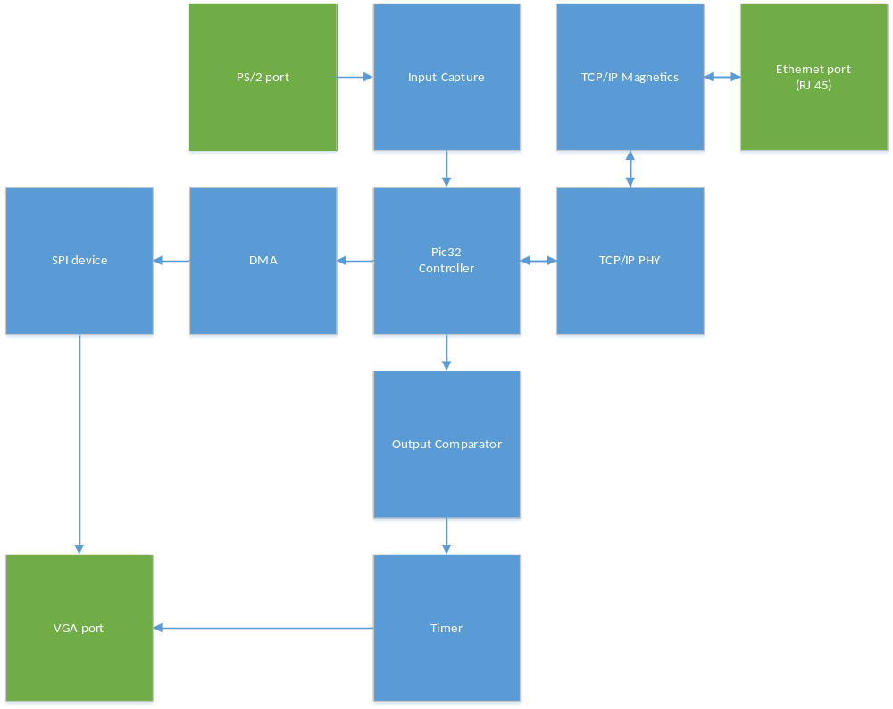

There are three major sections to the software, timer ISR, input capture ISR, and main loop.
The timer ISR controls the v-sync pin, and updates the DMA pointers so the transfer moves from line to line of the video memory.
The input capture ISR interrupts every time there is a falling edge and records 11 of them in a row to get a PS/2 scan code. Once this scan coded has been created, it is put into a circular buffer and a flag is set, then the ISR ends.
In the main loop, the system first initializes everything, then enters a loop of checking if there are any new keypresses using the aforementioned flag, then continues to the TCP/IP communication. If the flag is set, all of the scan codes currently in the buffer are processed. First they are turned into ascii. After that, the ascii characters are inserted into a “line” where they can be processed, and are also converted into 8x8 bitmaps that are copied onto the video buffer. After the “line” is interpreted, many different commands can be executed depending on the content of the line, such as setting the target IP. Currently the system only does things with the settargetip command, but other commands are able to be interpreted. Also currently, the system sends the currently entered line over TCP/IP as fast as possible, but sometimes double sends and doesn’t return any information.
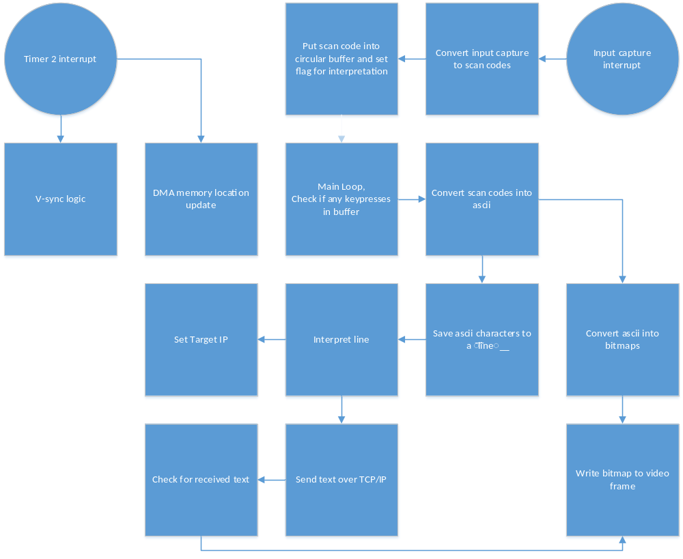

[This section should be written during the second or third term of senior project sequence.]

Architecture
Include relevant architecture elements of your design and explain them. (3-5 pages including figures)

This system is divided into two crucial segments, one for the PC hosting computer and one for the hardware device. The PC portion of things has two major parts, a TCP/IP communication part that allows it to talk to the microcontroller, and a system shell interface that allows sent text to be executed and returns the result of the shell command that is printed to the command line.
The hardware has four major parts, a TCP/IP communication part that allows it to talk to the host PC, a keyboard interpretation library that allows for keyboard input, a video output library that allows for textual output, and an interpretation shell that processes inputted instructions.
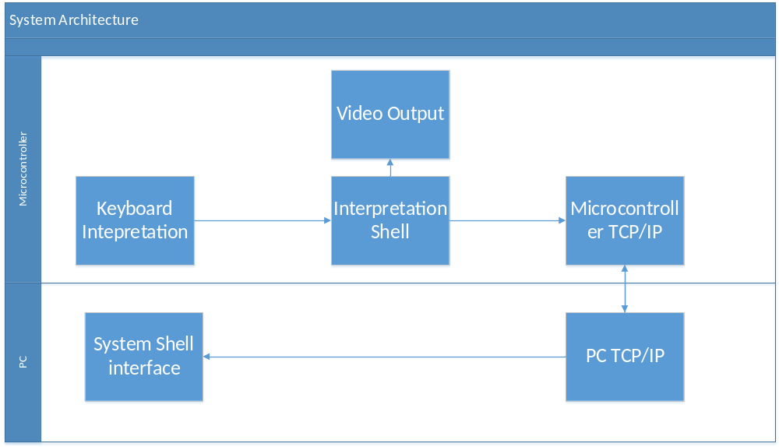

(Honestly I don’t really understand why we do this part. I see nothing unique to this section that shouldn’t be in the detailed description. A good description of the two sections and what they are for would be very useful.)
[This section should be written during the second or third term of senior project sequence.]

Summary

Summarize the chapter

[This section should be written during the second or third term of senior project sequence.]

Test Results & Validation

Overview

Provide an overview of the chapter here.
[This section should be written during the second or third term of senior project sequence.]

Test Plan

Describe your test plan and validation study.

[This section should be written during the second or third term of senior project sequence.]

Test Results

Include figures, screen shots, usability results, etc. of your test results. (3-5 pages)

[This section should be written during the second or third term of senior project sequence.]

Discussion

Provide a discussion of your test results. Does your design meet all the specifications? (2-5 pages)

[This section should be written during the second or third term of senior project sequence.]

Summary

Summarize the chapter
[This section should be written during the second or third term of senior project sequence.]

Economic and IP Analysis

Overview

Provide an overview of the chapter here. For some projects, this chapter may not be relevant.

[This section should be written during the second or third term of senior project sequence.]

Engineering Economic Analysis

Include the details of a basic engineering economic analysis. Make sure to include the cost of parts, R&D, engineering time, etc. (1-2 pages)

[This section should be written during the second or third term of senior project sequence.]

Intellectual Property Analysis

Address any issues related to intellectual property here. These may include Copyright, Trademark, Patent, or Trade Secret considerations that have affected your project or should be taken into consideration. (1-2 pages)

[This section should be written during the second or third term of senior project sequence, but issues should be checked during the design process.]

Summary

Summarize the chapter

[This section should be written during the second or third term of senior project sequence.]

Summary

Overview

Provide an overview of the chapter here.
[This section should be written during the third term of senior project sequence.]

Project Summary

Provide a summary of the project. (1 page)
[This section should be written during the third term of senior project sequence.]

Future Direction

Discuss potential future directions or possibilities for improvement. (1 page)
[This section should be written during the third term of senior project sequence.]

Concluding Remarks

Include some concluding remarks.
[This section should be written during the third term of senior project sequence.]

References

Include references using IEEE transactions citation format here.

Appendix

Use the appendix to attach additional schematics, code, and other relevant reference material that has not been included as part of the report. If these documents are to be printed separately and attached with the rest of the report a posteriori, please use this section to create a table of contents and provide a short explanation/overview of each of the documents attached.

